Brick Breaker - A Game

This is another of my game which is very primitive and unfinished. Anyone interested to develop the game further is welcome.  
  
Here is how the UI looks like...

[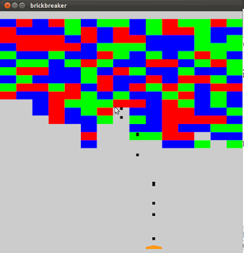](http://2.bp.blogspot.com/-WoxjLKMzXy8/UfEtGaaYJiI/AAAAAAAAANI/_0vBPQS4E_s/s1600/Screenshot+at+2013-07-25+19:15:39.png)

As you can see after running the code the game is partially complete and there is no end. If you want to show this as your computer graphics project you are free but you need to complete it.  
This is a list of problems that need to be overcome.  
1) The bullets seem to pass through the bricks and the brick vanishes a little late.  
2) There are ten bullets used here and they are recycled. That is a bullet which passes through or which blasts a brick, its position is reinitialized to the muzzle of the shooter from where it is shot again. The problem is two bullets have a tendency to be shot together or close to each other. This looks so much uncool. We would want distance between bullets to be equal.  
3) Even if a single brick comes near to the shooter region the game should end. I have deliberately left it unfinished. If you can write code to finish the game then it is a great thing. You can claim a little credit for having worked on this project. If you are able to solve the problems i mentioned earlier then you are a pro. If you manage to do so and if you are magnanimous enough you can get me the code and i will share it with everyone after giving you the credit.